

School of Computing, Engineering & Digital Technologies

Teesside University

Middlesbrough TS1 3BA

Customer sentiment analysis on airlines using NLP Techniques

Submitted in partial requirements for the degree of

**MSc Artificial Intelligence (Advanced Practice)**

Date: 10/01/2024

Jampani Venkata Pavani

W9577649

Supervisor: Hassan, Mahmadul

**Acknowledgement**

My Sincere Thanks to my supervisor Hassan Mahmadul, staff at Teesside University, my family and friends.

##### Abstract

This research aims to comprehend customer sentiments concerning airlines through the application of computer techniques to analyze and interpret customer reviews. The utilization of these techniques assists airlines in gauging their areas of proficiency as well as identifying aspects that require enhancement. A substantial collection of reviews was amassed from diverse individuals who had traveled with various airlines. Among these reviews, expressions of satisfaction were juxtaposed with less favorable remarks. Employing specialized methodologies, the researchers processed this plethora of textual input, extracting meaningful insights. The computer software devised for this purpose exhibited the capability to discern the sentiment conveyed in each review, categorizing them as positive, negative, or neutral. The program exhibited remarkable efficacy in this regard, enabling a comprehensive understanding of the factors that elicit contentment or discontent among travelers. Noteworthy details such as preferences for certain amenities like comfortable seating and grievances such as issues related to flight reservations or baggage complications were unveiled. The outcomes of this endeavor hold significant potential for the aviation industry. Airlines can capitalize on the unfavorable aspects pinpointed in customer feedback to effect improvements. Concurrently, they can perpetuate practices that garner appreciation from their patrons. In doing so, airlines can enhance customer satisfaction, fostering loyalty and repeat business. In essence, the study underscores the substantial utility of employing computational tools to decode customer sentiments regarding airlines. This approach serves as a poignant reminder for airlines to heed their customers' opinions, adapting in areas where necessary. This responsiveness is crucial for airlines to thrive within the expansive realm of travel choices and ensure customer contentment. Upon text cleaning and preprocessing the text employed TF-IDF Vectorization, and then tested many machine learning models. Notably, Logistic Regression and XGBoost exhibited the highest accuracy of 74%.

##### Table of Contents

Abstract i

Table of Contents ii

List of Figures iv

List of Listings iv

List of Tables v

List of Abbreviations v

1 Introduction 1

1.1 Background of Study 1

1.2 Purpose of Study 2

1.3 Aim and Objectives 2

1.3.1 Objectives 3

1.4 Research Question 3

1.5 Research Contribution 3

1.6 Research Methodology 4

1.7 Outline of Thesis 5

2 Literature Review 6

2.1 Existing Research 6

2.1.1 Traditional Methods 6

2.1.2 Modern Methods 7

2.2 Role of Customer Sentiment Analysis on Airlines using NLP 8

2.3 Related Work 10

2.4 Identification Gaps 15

3 Methodology 21

3.1 Overview 21

3.2 Natural Language Processing 21

3.3 Ensemble Techniques 23

3.3.1 Random Forest Techniques 23

3.3.2 Gradient Boosting and Extreme Boosting Techniques 25

3.3.3 ADA Boosting Techniques 26

3.3.4 Decision Tree 27

3.4 Summary 28

4 Result and Analysis 29

4.1 Overview 29

4.2 Data Description 29

4.3 Execution steps for completing this project 30

4.4 Import Libraries 31

4.5 Data Loading 31

4.6 Data description 32

4.7 Data Visualization 35

4.8 TF IDF Vectorization 41

4.9 Data Modeling 41

4.10 Final Result of The Project 44

4.11 Summary 44

5 Conclusions, Recommendations, and Future Scope 46

5.1 Conclusion 46

5.2 Recommendation 46

5.3 Future Scope 47

6 References 49

##### List of Figures

Figure 1.1 Research Methodology 4

Figure 2.1 Scores of various algorithms 11

Figure 2.2 The sentiment analysis structure 13

Figure 2.3 Proposed Deep Learning Model Architecture 14

Figure 2.4 Comparison of scores of proposed model with different classifiers 15

Figure 3.1 Random Forest Architecture 24

Figure 3.2 GB Architecture 25

Figure 3.3 Adaboost architecture 26

Figure 3.4 DT architecture 27

Figure 4.1 First five rows of the dataset 32

Figure 4.2 shape of the dataset 32

Figure 4.3 Information of the dataset 33

Figure 4.4 statistical information about the dataset 33

Figure 4.5 Checking the Null Values Count 34

Figure 4.6 Unique value of target column 34

Figure 4.7 count plot for airline_sentiment 35

Figure 4.8 Distribution of sentiment categories 36

Figure 4.9 Airline sentiment related to tweet count 36

Figure 4.10 Distribution of negative reasons 37

Figure 4.11 Word Cloud for Virgin America Airline 38

Figure 4.12 Word Cloud for Positive Tweets of Virgin America Airline 38

Figure 4.13 Word Cloud for Negative Tweets of Virgin America Airline 39

Figure 4.14 Word Cloud for Tweets of United Airline 39

Figure 4.15 Word Cloud for Positive Tweets of United Airline 40

Figure 4.16 Word Cloud for Negative Tweets of United Airline 40

Figure 4.17 Classification report for logistic regression 42

Figure 4.18 Classification Report For random forest 43

Figure 4.19 Adaboost Regression 43

Figure 4.20 Classification report for SVM 44

Figure 4.21 Accuracy report for all the Algorithms 44

##### List of Listings

Listing 4.1 Importing Libraries 31

Listing 4.2 Read the CSV file 31

Listing 4.3 Cleaning the Text Column 35

Listing 4.4 TF IDF Vectorization 41

Listing 4.5 Data Splitting 41

##### List of Tables

Table 2.1 Identification of Gaps 15

Table 4.1 Dataset Description 29

##### List of Abbreviations

|  |  |
| --- | --- |
| **Name** | **Description** |
| ML | Machine Learning |
| DL | Depp Learning |
| RF | Random Forest |
| GB | Gradient Boosting |
| DT | Decision Tree |

# Introduction

## Background of Study

In the realm of business and organizations, the phrase customer sentiment encapsulates a world of emotions and opinions that individuals hold towards a company, supermarket, or any other entity (Dwivedi et al., 2021). This sentiment conveys whether customers are content with the services provided by an organization or whether their experience has left them dissatisfied. Indeed, customers hold a pivotal role in any business ecosystem, for their satisfaction directly influences their decision to return as future patrons. The intricate dance of commerce hinges on this crucial factor customer satisfaction. This study delves into the realm of sentiment analysis within the context of airlines, utilizing the powerful tools of machine learning. The central inquiry revolves around understanding the extent of customer satisfaction or dissatisfaction within this sector. Airlines, undoubtedly, rank among the largest and busiest industries today, seamlessly ferrying people to their destinations efficiently and safely (Morrison, 2022). Yet, within this bustling landscape, numerous players vie for attention. While choices prosper, the discontentment often voiced about service quality and ticket pricing cannot be ignored. The crucial point of this study is the identification of which specific airline services fail to meet customer expectations and, crucially, the underlying causes. This identification is essential because it spotlights potential dangers that might lead to the downfall of companies in the face of declining customer demand. The contemporary marketplace is crowded with competitors who offer similar services, often at competitive prices. Thus, maintaining a perfect standard of service is not merely a choice, but an imperative. Neglecting this facet could, over time, erode the very foundation of a business.

The dataset under consideration comprises a trove of tweets directed at various airline handles on Twitter. This data repository encompasses twelve columns, of which one bears the crucial sentiment of each tweet. The remaining columns offer a wealth of contextual information, exposing the content, origin, timing, retweet_status, and more of each tweet. The undertaking at hand involves the construction of machine learning. This model endeavors to predict the sentiment of a given tweet, leveraging the excess of additional information contained within the dataset (Sykora et al., 2022). The interplay of variables, each conveying a facet of the tweet, contributes to an intricate tapestry of sentiment analysis. Intrinsically, this study is a marriage of technology and human experience, aiming to decipher the unspoken emotions buried within the digital expressions of customers. By comprehending these sentiments, organizations can uncover areas of improvement, enhance service quality, and adopt an environment where customers feel truly valued.

## Purpose of Study

The study's primary focus is to tackle the mounting concern surrounding customer dissatisfaction within the airline sector. A discernible pattern has materialized wherein a notable percentage of individuals are voicing their discontent, primarily centered around ticket prices. Unforeseen and disproportionate price surges, paired with a perceived deterioration in service standards, have become overt. Hence, the study's objective is to distinguish and pinpoint the airline establishments that are lacking in delivering satisfactory provisions to their clientele. Through an exhaustive analysis, the study strives to illuminate the precise problematic areas and contribute to a deeper comprehension of the underlying causes driving customer dissatisfaction in this arena.

The impetus behind initiating this study stems from the prevalent predicament of widespread customer discontent within the domain of airline amenities. Recent observations have underscored a growing pattern of dissatisfaction, particularly concerning the affordability and perceived value of ticket costs. This unease is exacerbated by instances where airlines have seemingly escalated ticket prices without a corresponding enhancement in service caliber. In response to these hurdles, the study endeavors to differentiate and isolate those specific airline entities that are falling short of meeting their customer base's expectations. By harnessing sophisticated Natural Language Processing (NLP) techniques and sentiment analysis, this investigation aspires to unveil nuanced perspectives derived from customer-generated content. These insights will elucidate the exact pain points and areas of discontent, thus fostering a more comprehensive apprehension of the challenges at hand. Ultimately, the study's purpose is to empower airlines and the industry in its entirety with actionable insights that can guide strategies toward heightening customer contentment. By identifying pivotal problematic zones, the study strives to instigate affirmative changes, enrich service quality, and reinstate customer faith in airline services.

## Aim and Objectives

### Aim

The aim of this work is to develop an Airline Sentiment Predictive model to analyse the Airline Tweets and Feedbacks to gain insights about the customer experience and across the Airline Industry.

### Objectives

* To develop a sentiment analysis predictive model in order to examine customer reviews related to Airline service providers.
* To utilize the sentiment analysis to gain insights to identify specific areas of improvement such as flight experience, baggage handling and customer service interactions.
* To analyse sentiments across the different airlines, present in the dataset and gain insights about the customer perception towards different airline service providers.
* To explore various Machine Learning Algorithm in developing the Predictive Model and select the best performing model.

## Research Question

* How does developing a Sentiment Analysis Prediction Model can help examine customer reviews of Airline Service Providers?
* How does Sentiment Analysis help to understand identify areas of improvement?
* Analyse sentiments across the different airlines present in the dataset and gain insights about the customer perception towards different airline service providers.
* How to evaluate various machine learning model and select the best performing model?

## Research Contribution

In this study the author performs sentiment analysis of Airline Tweets and develops a predictive model to predict the sentiment of tweet. The study is carried out by conducting the Exploratory Data Analysis initially which involves cleaning the tweets followed by Data Pre-processing which involves converting the document to embedding. This phase is very crucial as the embedding helps to convert the text information into the numerical vector representation such that it is understandable by Machine learning Algorithms. The main contributions of this work are as follows.

* Developing a robust Sentiment Analysis Predictive Model is one of the contributions of this work which can be utilized by various Airline Service Providers to analyse the sentiments of reviews.
* This work uses Sentiment Analysis to understand the specific areas of improvements and address the key issues expressed by Customers.
* The perceptions of customers across different airline service provider and a comparative analysis will be carried out in this work. This contributes to competitive analysis and strategic business decision making.
* Adding a geographical dimension to sentiment analysis to gain insights about customer sentiments across different locations is one of the contributions of this work.
* Exploring various ML algorithms in the development of predictive model and evaluating them for their performance is other contribution of this work. This contribution helps to identify the best performing model for Predictive model.

## Research Methodology

In this work of analysing and developing a sentiment analysis predictive model, initially a suitable dataset containing tweet and review of customer on airline service providers is collected. The Aims and Objectives are defined that the work is going to achieve. Following this a literature review is conducted to understand the work conducted by different researchers.

Figure 1.1 Research Methodology

This section explores the different techniques and methods used by researchers. Following the Literature Review methodology adopted in this work is explained. The Data then cleaned by removing the stop words and any unwanted words in the document. Data Pre-processing is carried out to convert the document to numerical vector and then the machine learning model is developed by implementing various algorithms. The models are then evaluated for performance and best performing model is selected based on better scores.

## Outline of Thesis

The Chapter 1 in this study discusses about the Introduction of the work and covers the background of study, purpose of the study along with aim and objectives. Moving to Chapter 2, a discussion of Literature Review is carried out. It contains sections like recent studies along with role of sentiment analysis. The chapter 3 discusses about the methodology where a discussion of different algorithms is carried out. Chapter 4 discusses about the results and analysis; and finally Chapter 5 discusses about the Conclusion, Recommendations.

# Literature Review

## Existing Research

The author is describing the existing research on airline customer satisfaction through sentiment analysis. The results of the airline analysis based on the satisfaction of the customers have been divided into two categories such as traditional approaches, it is discussing the earlier stages of the flight customer analysis, and another one is modern approaches, for the sentiment analysis of the customer online site reviews for the estimation of the tested data for the customers or airline passengers.

### Traditional Methods

In the traditional methods, the author has been used for the sentiment analysis for the commercial passengers for the airlines and they can relate with their satisfaction of the online reviews. The social media platforms are using textual data and analyze the responses of the tweets, and collect their research proposals and it is based on the lexicons and emotion lexicons (Higgins, 2022). The author has used the firstly NLP method for the detection of the analysis of the customer’s texted data and then used the various ML methods to predict the sentiment of customer analysis, the importance of the airline services is monitored in the approach and the methods are analysed and they have improved the offers for the services and the author has got 71% percentage of the naïve Bayes classification technique for the analyzing the online reviews of the satisfaction of the passengers. The author has used the NLP method to predict the consumer satisfaction level for analyzing the online reviews of the covid -19 pandemic before and after the analysis of the data. They have used the word embedding system and visual analysis for the level of the rating in the airlines finding the outcomes from the analysis (Gupta and Bhargav, 2022). The data can be predicted using the ML methods for the unrated aspects of the ratings and the existing data has been complemented and there to understand in an easier way to approach them for the airline industry. According to the Choi et al., social media platforms have served as rich sources of textual data, allowing researchers to gather a vast pool of customer responses, particularly on platforms like Twitter (Choi et al., 2020). Through the analysis of tweets and other online interactions, researchers have crafted research proposals that delve into customer sentiment using lexicons and emotion lexicons. This approach involves building lists of words associated with different emotions, enabling the classification of text into positive, negative, or neutral sentiments. The foundation of these traditional methods often starts with NLP techniques (Sharma and Ghose, 2020). By applying NLP, researchers preprocess and structure the textual data, transforming it into a format that can be analyzed. This process involves tasks such as tokenization, stemming, and removing stopwords, enhancing the quality of the data for subsequent analysis.

Various Machine Learning (ML) methods are employed to predict customer sentiments. These methods leverage the structured and labeled data to develop predictive models. Naïve Bayes classification is one such technique that has gained traction for sentiment analysis. By training the model on historical data with known sentiment labels, it learns to classify new, unlabeled data based on patterns it has discerned during training (Pugilese et al., 2021). In one study, the author employed a combination of NLP and ML techniques to monitor the importance of airline services through the analysis of customer reviews. By predicting sentiment, airlines could better understand how customers perceive their services and subsequently enhance their offerings. The study achieved a 71% accuracy using the naïve Bayes classification technique, indicating a significant success in assessing passenger satisfaction through online reviews.

### Modern Methods

In today’s generation, modern methods are used for the prediction of the analysis of customer reviews for their satisfaction level to be more focused on them and their spending a lot of money in the markets. The author has implemented the analysis of customer sentiment analysis for machine learning and NLP techniques are used (Tusar and Islam, 2021). The sentiment analysis of the services and products is finding the outputs for the online available data. They have used the SVM, logistic method, Naïve Bayes, etc, for the prediction of airline sentiment customer analysis. The data has been used in the research and has been considered to be the misbalancing and multi-classification data, it has got a 77% percentage of accuracy in the SVM and logistic regression of words methods. The author has used digitally texted data for the reviews of online site analysis. The researchers are increased based on the applications in the future, they analyzed the fundamental relationships with their methods. In the marketing analysis, there are so far in the integrations. The neural networks methods are based on the ML methods, the author has pre-trained the data for the diagnosis and prediction to selective methods to be procured and reviewed the textual data to liked and analyzed for the objective in the diagnosis versus the prediction of future (Alantari et al., 2022).

Modern methods of predicting and evaluating customer reviews have gained importance in the present environment to increase the level of customer satisfaction (Ahani et al., 2021). Businesses are increasingly focusing on meeting the demands and preferences of consumers as they invest huge amounts of money in various markets. In this regard, the authors have used sophisticated methods, especially machine learning and natural language processing (NLP), to analyze customer sentiment in more detail with the aim of extracting useful information from their input.

Modern approaches include a wide range of machine learning algorithms, each specifically designed for the complexity of sentiment analysis. Naive Bayes, logistic regression, and support vector machine (SVM) are some of the well-known techniques used to predict customer sentiment in the airline sector. These methods use labeled data to train their models and identify patterns and relationships in textual data. In their research, researchers frequently face problems caused by unbalanced and multi-categorized data. Despite these difficulties explained by Rathee et al., (2018). their efforts have yielded encouraging results. For example, a study using SVM and logistic regression of words was able to predict sentiment with respect to airline customer data with 77% accuracy.

## Role of Customer Sentiment Analysis on Airlines using NLP

Customer sentiment analysis has emerged as a pivotal component within the airline industry, facilitating enhanced customer interactions through the utilization of Natural Language Processing (NLP) techniques and machine learning methodologies. This analytical approach has significantly transformed the manner in which airlines engage with their customers across online platforms, propelling communication and customer experience to new heights (Ferreira et al., 2023). The fundamental process of customer sentiment analysis within the airline sector begins with travellers sharing their individual experiences on various online platforms. These customer reviews form the bedrock upon which sophisticated data analysis models are constructed, aimed at accurately predicting sentiments and opinions (Jain et al., 2023). These models heavily rely on manually crafted rules specifically designed to dissect the polarity, subjectivity, and opinions articulated by customers in their online feedback.

One of the pivotal rule-based methodologies encompassed in this process involves stemming, tokenization, parts of speech tagging, and parsing (Yogish et al., 2019). These linguistic techniques dissect sentences into constituent components, allowing for the extraction of sentiment-bearing words and phrases. Furthermore, lexicons – repositories of words and expressions laden with sentiments – constitute another rule-based approach, enabling the classification of sentiments into positive, negative, and neutral categories. These approaches leverage a comprehensive pool of polarized words, aiding in the accurate determination of sentiment (Shen and Shafiq, 2020). In the context of sentiment analysis within customer reviews in the airline industry, several machine learning algorithms come into play. Naive Bayes, renowned for its efficacy in probabilistic classification of textual data, offers a viable choice for sentiment classification (Rahat et al., 2019). Support Vector Machines (SVM) excel in capturing intricate relationships between features and labels, while Random Forest algorithms combine decision trees to mitigate overfitting and enhance robustness. Recurrent Neural Networks (RNNs), particularly Long Short-Term Memory (LSTM) and Gated Recurrent Unit (GRU) variants, hold promise in capturing contextual information and are beneficial in analyzing sentiment within sequential data (Rahat et al., 2019).

The advent of transformer-based models, such as BERT and GPT-3, introduces compelling alternatives for sentiment analysis within the broader NLP landscape. These models excel in comprehending contextual nuances, proving especially adept at grasping intricate sentiment dynamics (Kumar et al., 2021). Choosing the most suitable algorithm hinges upon factors including the available data, feature extraction methods, and task complexities, demanding a comprehensive cycle of experimentation and optimization. The evolution of sentiment analysis within the airline industry has ushered in advanced techniques that integrate novel expressions and vocabularies, resulting in the formulation of new rules that amplify the precision of customer review analysis. The ever-evolving nature of language necessitates the continuous refinement of these rules to capture shifting sentiments accurately (Boddu et al., 2022). Subsequent to rule-based analysis, machine learning strategies refine sentiment analysis autonomously, extrapolating sentiments from discernible patterns.

A noteworthy trend is the emergence of hybrid systems, encompassing both rule-based and machine-learning paradigms, to achieve a more holistic sentiment assessment (Iqbal et al., 2019). This multifaceted approach aligns with the dynamic nature of customer feedback and positions airlines to glean comprehensive insights into preferences, areas for improvement, and potential crises. These insights pave the way for tailored services and experiences, thereby augmenting brand perception and engendering customer loyalty. The ramifications of sentiment analysis extend beyond mere feedback assessment. Positive sentiments magnify the resonance of favorable experiences, while the identification of negative sentiments empowers airlines to address concerns and mitigate issues promptly (Morgan et al., 2020). Consequently, sentiment analysis serves as an invaluable tool in refining marketing strategies, optimizing service offerings, and streamlining operational processes to meet and surpass customer expectations.

In the ever-evolving landscape of the airline industry, customer sentiment analysis is effecting transformative change. By harnessing the intricate interplay of Natural Language Processing and machine learning, airlines are positioned to not only comprehend customer sentiments comprehensively but also to adapt and innovate to better serve their clientele (Ajah and Nweke, 2019). This customer-centric approach is poised to revolutionize the airline sector, ultimately shaping its trajectory in alignment with the desires and preferences of its customers. The profound impact of customer sentiment analysis in the airline industry lies in its ability to reshape the customer-centric landscape. By amalgamating the intricate dynamics of Natural Language Processing and machine learning, airlines are not only empowered to comprehensively grasp customer sentiments but also to proactively evolve and innovate in response to customer feedback. This adaptive approach is poised to revolutionize the airline sector, propelling it toward a trajectory harmonized with the evolving desires and preferences of its customers. Through sentiment analysis, airlines not only refine their service offerings and marketing strategies but also cultivate a deeper understanding of their clientele, fostering enduring brand loyalty and fortifying their position in a highly competitive market (Ibrahim and Wang, 2019). This amalgamation of advanced technologies and customer insights engenders a symbiotic relationship between airlines and their customers, wherein the voice of the customer becomes the compass guiding the industry's progression.

## Related Work

Analysis of Airline Sentiments and Feedbacks is very crucial because of the fact that it provides important insights about the sentiments and consumer experience. There are many research studies conducted by different researchers across globe in developing the sentiment analysis predictive model. In this direction Prabhakar et al., (2019), discusses the significance of Airline Sentiment in the context of Airline service providers as they are very useful in helping the customers to choose the Airline. In this study the author discusses the effect and influence of internet as they provide the platform to express the thoughts and feedbacks of peoples and customer and this greatly impacts the decision making regarding the selection of airlines. In such scenarios sentiment analysis plays a significant role in understanding the customer experience and this serves as valuable tool for Airline Service Providers to make strategic decisions. In this work, improved Adaptive Boosting Ensemble Learning approach is utilized and the evaluation of model is carried out by utilizing the Confusion Matrix and Accuracy Scores.

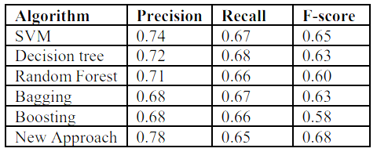

Figure 2.1 Scores of various algorithms

Source: Prabhakar et al., (2019, p.3)

While analysing the tweets or any other data from social media platforms carrying out sentiment analysis becomes challenging as the tweets and often unstructured and noisy. This imposes the challenges and difficulties in understanding the context and dealing with words which contains multiple meanings. In practical cases, the twitter data is very noisy where the existing approaches fails as the existing approaches rely on cleaning the text data. Naseem et al., (2019), addresses this challenge by proposing a new technique of representing word. The study proposed hybrid words representation and Bi-Directional Long Short-Term Memory (BiLSTM) with attention modelling which provides various advantages. The advantages like improvement in the tweet quality has been observed by treating the noise in the textual context and also considers polysemy, semantics, and out of vocabulary works. The proposed model overcomes these limitations and improve the accuracy of tweets. Kumar and Zymbler, (2019), employs a machine learning approach, utilizing features extracted from tweets through word embedding with the Glove dictionary approach and n-gram approach. The classification model is developed using Support Vector Machine (SVM) and various Artificial Neural Network (ANN) architectures to categorize tweets as positive or negative. Additionally, a Convolutional Neural Network (CNN) is implemented and compared with SVM and ANN models, with CNN demonstrating superior performance. The study also showcases the application of association rule mining on different tweet categories and observed that valuable associations can help the airline service providers to improve their customer experience. Sreeja et al., (2020), highlights the why it is important to understand the opinions of customers regarding the airlines particularly in the case of Indian Airlines. Customer experience plays a very important role because every day about 100000 flights are taking people from across the globe to different destinations and understanding the customer experience and sentiments plays a significant role. Twitter data is considered the best source for this information. The focus is on analyzing customer views on Indian Airlines services, using data visualization to display feelings such as anger, fear, anticipation, trust, surprise, sadness, joy, and disgust. The overall sentiment is categorized as either positive or negative based on customer opinions.

Saad, (2020), highlights that the airline sector is growing in the market because of many people using Airlines to travel across the different places in the world. Opinion mining plays a key role in this sector. One of the techniques to carryout text sentiment analysis is by using natural language processing techniques to analyse the textual data. In this study the author utilized the opinion mining technique to gain insights about the customer feedback regarding the airlines service providers. The research proposes a machine learning model to categorize tweets into positive, negative, and neutral sentiments for six different US airlines. The process involves cleaning and extracting features from tweets, using the Bag of Words (BoW) model. Different Machine Learning algorithms like SVM, LR, RF, XGB, NB and DT are used in developing the classification model. The study also applies the K-Fold Cross-Validation to reduce the over-fitting. The results demonstrate that Support Vector Machines (SVM) has achieved the highest accuracy score of 83.31%. Apart from the accuracy score, Precision Score, Recall Score and F1-Scores for each classifier is obtained. Lucini et al., (2020), uses the text mining method to explore the online customer reviews known as OCR and this analysis helps to provide the guidelines to airline service provides to improve their business and competitiveness. In this study the data from more than 55000 OCR are obtained spanning 400 airlines and passengers across the 170 countries. To handle the curse of dimensionality the Latent Dirichlet Allocation model was utilized which identified 27 dimensions. Dimensions and Adjectives played a key role in predicting the airline recommendation with accuracy of 79.95%. Practical implications suggest that airlines should focus on customer service for first-class passengers, comfort for premium economy passengers, and checking luggage and waiting time for economy class travelers to maximize customer satisfaction. Regression analysis identifies cabin staff, onboard service, and value for money as top dimensions for predicting airline recommendations, suggesting that improving services in these areas can enhance overall performance with customers. Ullah et al., (2020), says emoticons with text have been neglected during the analysis which has led to loss of information about the emotions and sentiments. Earlier, ML techniques were used to classify text or images solely. In this study the author proposes the algorithms for sentiment analysis which combines both text and emoticons. Different text preprocessing techniques like TF-IDF, Bag of Words, N-Gram and emoticon lexicons. Separate analysis of text and emoticons and combined analysis of text and emoticons are carried out by using Machine Learning and Deep Learning techniques. The results demonstrated that emotions from emoticons conveys more emotions when people used text along with emoticons and also deep learning algorithm found to be performing better than machine learning models. The proposed methodology is shown in Fig. 2.2.

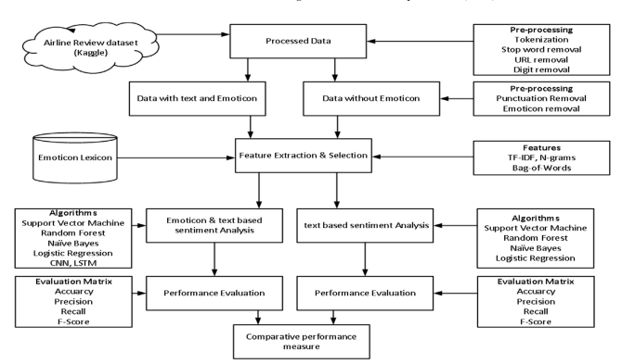

Figure 2.2 The sentiment analysis structure

Source: Ullah et al., (2020, p.360)

Iqbal et al., (2020), compare the performance of various supervised learning classification techniques, such as Gaussian Naïve Bayes, Decision Tree, Support Vector Machines, and Random Forest, to determine the most suitable algorithm for sentiment analysis of a dataset. The dataset used consists of tweets from US airline users, and the analysis aims to contribute to improving airline services by identifying the best technique for sentiment classification. The author further highlights that micro-blogging like tweets is gaining popularity for providing the rich content which is useful in sentiment analysis.

Sentiment analysis is gaining popularity because the insights and information from such analysis is of great help to service companies like airlines which can use this insights to design and implement the informed decisions and strategy to improve the customer experience and improve customer’s image for a particular company. Zaki Ahmed and Rodríguez-Díaz (2020), proposes a framework to classify the sentiment lables based on the quantitative variable like overall ratings. The methodology is applied to extensive online customer reviews to validate the relevance of the identified tags for assessing sentiments. The results indicate that labels from titles are valid for analyzing feelings in comments, simplifying the sentiment analysis process for online customer feedback. Kwon et al., (2021), analysed posts from Skytrax (airlinequality.com), is a platform where customers share their experiences and opinions about airlines. In this study reviews were collected from online customers who have used airlines in Asia, from a total of more than 14,000 reviews across 27 airlines. Using topic modelling and sentiment analysis, the study identified important words in these reviews. Results showed that issues like 'seat,' 'service,' and 'meal' were significant topics in flights, while delays were a major concern affecting customer dissatisfaction. Ravi Kumar et al., (2021), performed a test where three ML techniques was utilized on US Airline Twitter Information and data was collected form Kaggle. The algorithms like Decision Tree, SVM and Neural Network was utilized and evaluated for accuracy. It was observed from the results that Neural Network approach has perceived a most highest accuracy score of 75.99%. Hasib et al., (2021), introduces the deep learning approach which makes use of different word embedding techniques. This approach was tested on dataset containing tweets and feedback from different customers from 6 major US Airline Service Providers. The methodology involved data extraction of the tweets followed by cleaning.

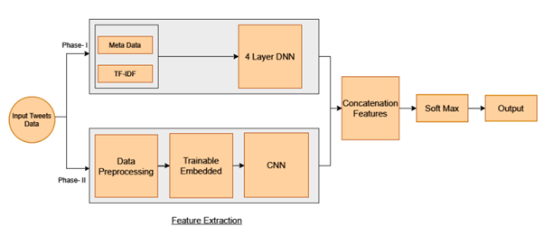

Figure 2.3 Proposed Deep Learning Model Architecture

Source: Hasib et al., (2021, p.452)

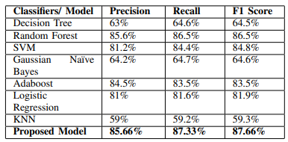

Figure 2.4 Comparison of scores of proposed models with different classifiers

Source: Hasib et al., (2021, p.454)

The results demonstrated that proposed method is performing better than other classification models like Decision Tree, Random Forest, SVM, Gaussian Naïve Bayes, Adaboost, Logistic Regression and KNN with F1-Score of 87.66%.

## Identification Gaps

Table 2.1 Identification of Gaps

|  |  |  |  |  |
| --- | --- | --- | --- | --- |
| **SI. No** | **Title And Author** | **Technique Used** | **Result** | **Gaps** |
| 1 | Sentiment Analysis of Customer Feedback and Reviews for Airline Services using Language Representation Model  (Patel et al., 2023). | Machine Learning Method (ML)  It is used as a classification method for this dataset. | The random forest method compared to the BERT model was the best performed in the ML methods. | There is the text and data were supplied to the sentimental analysis of the airlines for the attitudes and emotions of the consumers. |
| 2 | Predicting aspect-based sentiment using deep learning and information visualization: The impact of COVID-19 on the airline industry (Chang et al., 2022). | The author has used machine learning (ML), Natural Language Processing (NLP), and deep learning techniques (DL). | The data has been outperformed using the ML method for the prediction of the unrating aspects of customer reviews. | They have identified the research gap of the unrating level of the customer reviews sentiment analysis. |
| 3 | Sentiment Analysis of Twitter Data for Better Services of Airlines Using Classifier-Model Algorithms, AI, and NLP Techniques (Ahmed et al., 2022) | In the dataset, the author has used machine learning and natural language processing, deep learning techniques for customer sentiment analysis. | The author has described that outperforms the classification methods using various ML methods | The gap is identifying the un textual data in these research papers |
| 4 | Sentiment analysis on Twitter data integrating TextBlob and deep learning models: The case of US airline industry Aljedaani et al., (2022). | The author has used various Machine learning techniques and deep learning methods in the analysis of the airline sentiment analysis of the customer’s online reviews. | The results have got an optimum solution for the 92% of the support vector machine and extra tree classification method. | Here the author does not mention the sentiment analysis of the airline industry. |
| 5 | Opinion Mining on US Airline Twitter Data Using Machine Learning Techniques (Saad, 2020). | In the dataset, the author has used various methods in machine learning techniques, and Natural language processing (NLP). | The results of the dataset have a got 6the training 70% and 30% for the testing and at last, the SVM method has got the 83% of the highest accuracy in the classification of the ML. | The author does not mention clearly the gaps in the opinions of the sentiment analysis of the airline’s reviews of the passengers. |
| 6 | A sentiment analysis of airline system using machine learning algorithms (Tusar and Islam, 2021). | In this paper, the author take Airline Dataset from Twitter and did sentiment analysis on that dataset using machine learning algorithms like SVM, Naïve Bayes and Random Forest. | SVM is the best algorithm for binary classification and gave accuracy above 90% random forest also gave the best accuracy. | Effective text pre-processing, encompassing tasks like punctuation removal, lowercase conversion, and contractions handling, contributes to cleaner data for analysis. Feature engineering plays a pivotal role, involving the exploration of diverse text representation methods such as TF-IDF, word embeddings, and contextual embeddings like BERT or GPT. |
| 7 | Sentiment Analysis using Feature Extraction and Dictionary-Based Approaches (Deepa and Tamilarasi, 2019). | Feature engineering techniques like CountVectorizer, TF-IDF, Word2Vec by using machine learning classifier | Machine learning approach compared the accuracy with CountVectorizer, TF-IDF and Word2Vec. For dictionarybased approach compared with SentiWordNet and VADER | performance can be improved by using more algorithms like Naïve Bayes, Linear SVM and Artificial Neural Network and optimization techniques can be performed for score adaptation to increase the accuracy in Dictionary based approach. |
| 8 | A text analytics-based importance performance analysis and its application to airline service (Nam and Lee, 2019). | the method described in the text is "TAIPA" (Text Analytics-based Importance-Performance Analysis), which is introduced as a novel approach for analyzing customer perceptions, evaluating service quality, and providing insights for strategic decision-making based on online reviews with numerical ratings | TAIPA is more effective than comparison targets in that it shows stronger correlations with firm performance. | In order to improve a one-to-one interaction with a service encounter, TAIPA specializes in identifying which service step has to be addressed. Additionally, TAIPA is adaptable when taking into account various rivals. |
| 9 | A survey of sentiment analysis: Approaches, datasets, and future research Tan et al., (2023). | Use of ensemble models with various machine learning algorithms, such as naive Bayes, support vector machines, random forests, logistic regression, and XGBoost, was employed in a number of studies on sentiment analysis. | The ensemble models utilized in sentiment analysis had accuracy levels between 80% and 98.99%. | Some research used methods including case folding, stop-word removal, stemming, N-grams, and TF-IDF vectorization to preprocess the datasets. |
| 10 | Topic modeling and sentiment analysis of online review for airlines  Kwon et al., (2021). | The study made use of text mining methods such document-term matrix (DTM) transformation, Latent Dirichlet Allocation (LDA) for topic modeling, word cloud visualization, and emotional analysis. Preprocessing (cleaning, transformation, stopwords removal, stemming) was also used. | Key findings were gleaned from the research of online reviews: Positive descriptors like 'good,' 'comfortable,' and 'friendly' represented positive airline service. Negative adjectives like "delayed" and "poor" pointed up areas that needed improvement. Significant keywords were highlighted by word clouds, and topics like "In-flight meal" and "Entertainment" were found using topic modeling. | The study doesn't go into much detail about the context of negative terms. It doesn't take into account possible differences in client preferences or cultural quirks. Additionally, a qualitative analysis might offer deeper understandings of sentiment, adding to a more thorough understanding of client perspectives. |

# Methodology

## Overview

Overview explores a comprehensive strategy in the subject of customer sentiment analysis in the airline sector. NLP which enables computers to perceive variations in human language, is discussed in detail in Section 3.2. Moving on to Section 3.3, Ensemble Techniques become effective tools for enhancing sentiment analysis. Particularly noteworthy is Section 3.3.1's discussion of the Random Forest Techniques, which combine predictions from various models. Iteratively improving sentiment understanding, Section 3.3.2 examines the dynamic environment of Gradient Boosting and Extreme Boosting Techniques. As discussed in Section 3.3.3, ADA Boosting Techniques precisely modify weights to improve accuracy. In Section 3.3.4, Decision Trees, which accurately interpret emotions, add to the suspense. This thorough investigation comes to a conclusion in Section 3.4 with a summary that emphasizes the effectiveness of these strategies in interpreting consumer sentiments, and enhancing airline services and customer experiences in the cutthroat aviation industry.

## Natural Language Processing

The goal of NLP, which straddles the fields of linguistics, AI, and computer science, is to give machines the capacity to understand and engage with human language. NLP's fundamental goal is to create a link between the complex nuance of human communication and the organized realm of computational analysis. Syntax analysis and semantic analysis are two foundations that support natural language processing [15]. The placement of words within a phrase affects grammar and structural coherence. This is known as syntax. Similar to a building's blueprint, a sentence's syntax establishes the links between words and specifies how they should be used. Computers can interpret a sentence's syntax to determine the underlying grammatical structure and the functions that various words serve.

On the other side, semantic analysis explores the world of meaning. It engages with the intricacies concealed in words and phrases in addition to the language's surface structure (Johri et al., (2021). Words don't exist in a vacuum; they derive meaning from the environment in which they are used. Computers are given the ability to understand context through semantic analysis, allowing them to interpret the intended message. It's the distinction between realizing that, depending on the context, the word bank can refer to either a financial institution or the bank of a river. NLP is the foundation of the author's project. The text and airline sentiment columns in the dataset contain a wealth of insightful data that is just ready to be retrieved and analyzed (Hasib, 2022). The preparation of this textual input is made easier by the arsenal of techniques available to NLP. The next step entails a series of transformational actions that get the data ready for more in-depth study. The first gatekeeper is shown to be tokenization. Text is divided into discrete tokens, such as words or sub words, allowing the computer to understand the fundamental elements of the language. Therefore, this segmentation makes it possible to do further analysis and lays the foundation for comprehending the structure of the text.

Following, stemming and lemmatization provide a connection between various word forms. Stemming is the process of reducing words to their most basic form by omitting suffixes, which enables the computer to connect many spellings of a single word (Ebrahim, 2023). A more advanced method is lemmatization, which takes into account the context of a word before simplifying it to its dictionary-basis form. These methods enable more efficient analysis by reducing the size of the data while maintaining its core. As a grammatical compass, part-of-speech (POS) tagging enters the picture. Nouns, verbs, adjectives, and other labels are used to categorize words. This tagging clarifies the grammatical landscape of the sentence, assisting the computer in comprehending the relationships.

Chunking advances our understanding by assembling words into meaningful chunks. It puts words together according to how they relate to one another grammatically to produce longer structures that contain meaning. Chunking is similar to putting together a jigsaw, where each component adds to the overall picture. NLP combines these methods in a great symphony of linguistic analysis to thoroughly preprocess the text (Vajjala et al., 2020). Why, therefore, is this preprocessing so important? It's like washing, polishing, and organizing a canvas before painting so that the artist's vision can be seen. For data scientists and analysts, this synthesis of methodologies serves as a toolset. The author's analytical skills are enhanced by the cooperation of tokenization, stemming, lemmatization, part-of-speech tagging, named entity recognition, and chunking. It changes the text from an unstructured string into a blank canvas that may be painted on with insights (Yogish et al., 2019). In the process of interpreting human language, NLP stands out as a significant protagonist. Its dual focus on syntax and semantic analysis reflects the structure and meaning-driven character of language. The use of these methods will have a significant positive impact on the author's project. Therefore, NLP understands the language of data to provide insights that fuel modern thinking and innovation, much like how linguists decode ancient scripts to uncover buried histories (Li, 2020).

## Ensemble Techniques

Ensemble Techniques, enhanced by the complementary nature of NLP, stand out in the landscape of Customer Sentiment Analysis within the context of airlines as a beacon of predictive ability. Understanding client sentiments is a natural fit for NLP's capacity to decipher the nuanced intricacies of human language. Ensemble Techniques, such bagging, stacking, and boosting, enhance NLP's capacity to derive practical insights in this attempt (Ganaie et al., 2022). Bagging, also known as Bootstrap Aggregation, combines sentiment forecasts from different NLP models. It's comparable to polling a wide group of specialists, each of which has expertise in analyzing certain linguistic facets. This method combines these professional judgments, resulting in reliable sentiment predictions that take into consideration a wide range of language subtleties.

On the other hand, stacking brings together a group of NLP models, much as a group of sentiment analysts, each with their own area of specialization. These algorithms work together in tiers, with each layer improving the previous one's sentiment prediction. By utilizing each model's advantages, stacking improves the predictive power as a whole. With boosting, each NLP model learns from its past errors and develops a deeper knowledge of consumer attitudes over time, much like an iterative mentor (Vajjala et al., 2020). This method uses the combined intelligence of models to continuously improve sentiment forecasts, producing ever-more precise insights.

According to Sachine et al., (2020) ensemble Techniques provide an essential benefit in the field of customer sentiment analysis, where input can be complex and diverse. The outputs of various NLP models are synchronized, which reduces the biases and uncertainties of each model individually. More accurate sentiment analysis is frequently produced by the convergence of models than by using only one model. A thorough grasp of client feedback can be achieved in the airline business by using ensemble techniques to NLP-powered customer sentiment analysis. Airlines can identify trends, extract insights, and modify strategy to improve customer experiences by bagging, stacking, or boosting the capabilities of several NLP models (Ligthart et al., 2021) . Raw input is transformed into useful knowledge through a symphony of linguistic decoding and predictive understanding, enabling airlines to manage the constantly changing customer sentiment landscape.

### Random Forest Techniques

The use of the Random Forest algorithm gives a powerful strategy that smoothly interacts with NLP approaches for customer sentiment analysis in the airline business. A powerful ensemble learning algorithm called Random Forest provides a multidimensional approach that improves the precision and interpretability of sentiment analysis results (Aria et al., 2021). The foundation of the Random Forest approach is the construction of a collection of decision trees, each trained on various subsets of the dataset. These decision trees examine the grammatical nuance in customer feedback to determine the underlying sentiment orientation, much like sentiment detectors do. By making up for the shortcomings of individual decision trees, an ensemble technique promotes robustness. The interaction of Random Forest and linguistic insights in the context of NLP-driven sentiment analysis is revolutionary (Ankarang and Waldner, 2019). The complexity of consumer feedback complements the algorithm's capacity to handle complicated linguistic variations. Additionally, a thorough sentiment analysis result that can manage the complexity and diversity of textual material is produced by combining forecasts from many decision trees.

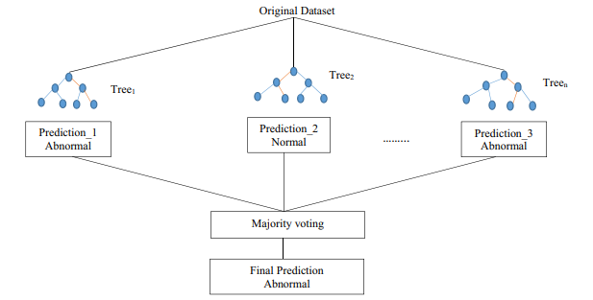

Figure 3.1 Random Forest Architecture

Source: Shafi et al., (2020, p.5)

Airlines now have access to a potent arsenal for deciphering client perceptions thanks to the mutually beneficial link between Random Forest and NLP. Airlines can extract thorough feelings by interpreting tiny verbal clues and combining information from many decision trees (Naseem et al., 2021). With the use of these insights, airlines are more equipped to understand customer attitudes and take strategic steps to improve services, address problems, and increase overall customer happiness. For airlines attempting to understand the complex world of consumer attitudes, the Random Forest algorithm works in collaboration with NLP approaches to become a valuable ally. Because of the way it works as an ensemble, it is able to maximize the potential of each decision tree, creating a comprehensive sentiment analysis strategy that provides a clear picture of consumer experiences in the airline industry.

### Gradient Boosting and Extreme Boosting Techniques

Gradient Boosting and Extreme Boosting Techniques become crucial partners in the context of Customer Sentiment Analysis in the airline business, effortlessly integrating with NLP techniques (Wankhade et al., 2022). These sophisticated algorithms enhance the precision and breadth of insights, which strengthen sentiment analysis. A powerful ensemble technique called gradient boosting creates a series of models, each of which corrects the flaws of the one before it. It resembles an ongoing learning process where each model improves its capacity for sentiment analysis. This approach is excellent at spotting minute sentiment fluctuations in consumer feedback, ideally complementing the nuanced nature of NLP-driven insights.

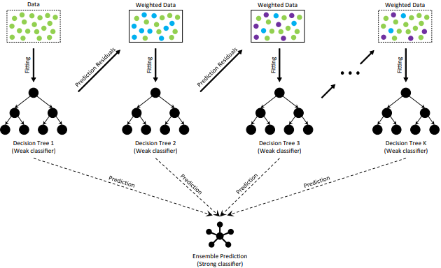

Figure 3.2 GB Architecture

Source: Deng et al., (2021, p.4)

This orchestration is advanced further by extreme boosting, also known as XGBoost. While adding enhancements that improve efficiency and predictability, it harnesses the power of gradient boosting. XGBoost fine-tunes the process, acting as a sort of turbocharger for sentiment analysis and enabling more subtle sentiment identification across various linguistic forms. Airlines now have powerful sentiment analysis capabilities thanks to the combination of gradient boosting and extreme boosting with NLP approaches. These computers are skilled at spotting nuanced linguistic indicators, picking up on both the overt and covert emotion in consumer reviews (Downie, 2019). Airlines can gain valuable insights by combining the advantages of these methodologies, allowing them to better customize their strategy, improve their services, and meet the needs of their customers.

### ADA Boosting Techniques

In the context of Customer Sentiment Analysis for airlines, ADA Boosting, a potent ensemble technique, integrates smoothly with NLP techniques. By iteratively changing the weights of misclassified examples, this technique aims to improve the precision of sentiment categorization. Like a dedicated learner who concentrates harder on difficult subjects, that's what it's like. ADA Boosting develops into a skilled interpreter of linguistic nuance in the context of NLP-driven sentiment analysis.

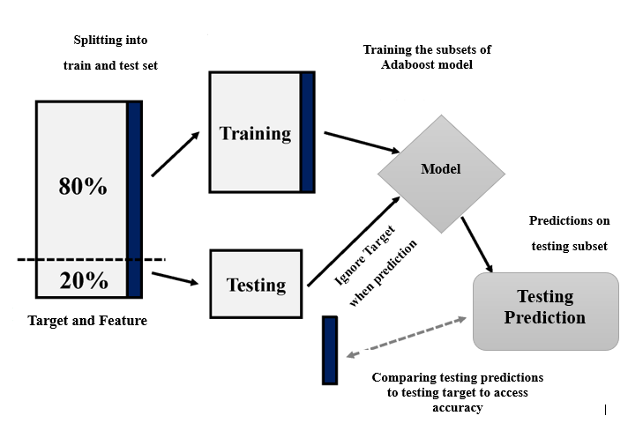

Figure 3.3 Adaboost architecture

Source: Wang et al., (2021, p.6)

Airlines can develop a more sophisticated knowledge of client attitudes by combining the benefits of ADA Boosting with NLP methods (Hasib, 2022). With the help of this pair, the computer can successfully discern between good and negative emotions, even in intricate linguistic patterns. In the end, ADA Boosting enables airlines to derive precise insights from consumer input, hence boosting customer satisfaction in the ever-changing airline market.

### Decision Tree

The strategic fusion of Decision Trees with NLP Techniques emerges as a compelling methodology that permits airlines to explore the complex world of client sentiments in the dynamic environment of customer sentiment analysis within the aviation industry. Decision Trees are algorithmic structures that methodically analyze data by making a succession of binary judgments (Budhiraja and Sharma, 2023). They are frequently compared to investigative agents. These trees are used in Customer Sentiment Analysis to analyze the linguistic cues in customer feedback and classify feelings into positive, negative, and neutral categories. Decision Trees' adaptability to complicated linguistic patterns and ability to effortlessly match the complexity of client expressions are what give them their versatility (Osama et al., 2020). By giving Decision Trees the ability to understand the context, tone, and complexities of language, NLP techniques enhance their abilities. Through this synergy, the computer is able to analyze not just the words but also the underlying emotional layers in consumer feedback, giving airlines a comprehensive grasp of sentiments that go beyond the obvious.

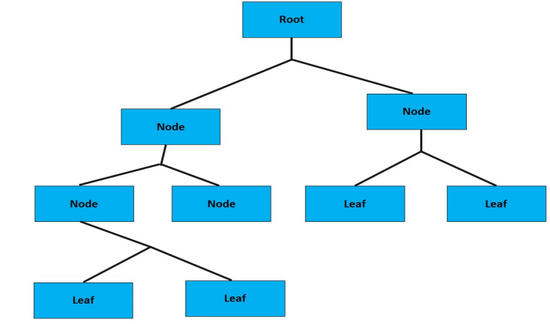

Figure 3.4 DT architecture

Source: Sadeghian Broujeny et al., (2023, p. 6)

Airlines looking to decipher client sentiments intricately can use the powerful tool provided by the symbiotic link between Decision Trees and NLP. This combination equips airlines to traverse the complex world of consumer feedback with accuracy and insight as technology develops and the aviation business changes (Keke, 2023). Airlines can gain priceless insights that improve services, boost customer satisfaction, and pave the road for long-term success in the cutthroat aviation industry by utilizing Decision Trees in conjunction with NLP Techniques.

## Summary

The opinions expressed on flight websites can be analyzed using a variety of techniques. To evaluate the sequential patterns of the prediction methods and investigate the process of the predictive modeled dataset for effective outcomes, a variety of machine learning algorithms are used. Real-time applications employ every machine learning technique to potentially produce the intended results. Using the decision tree and XGB classifier for result validation, the regression and classifier models are applied to the trained dataset to assist in identifying the dataset's errors. These methods and techniques can be used to handle complex issues and produce reliable results.

# Result and Analysis

## Overview

This chapter delves into the outcomes and examination of the project. Section 4.2 presents an extensive overview of the employed dataset, encompassing its structural attributes, column details, and variable characteristics. Section 4.3 outlines the systematic execution process undertaken to achieve successful project completion. It presents a clear roadmap of the sequential tasks executed to attain the final outcomes. Section 4.4 discusses the assortment of libraries harnessed in the project's code, spotlighting the specific libraries and their functions that played a pivotal role in conducting data analysis. Section 4.5 expounds on the data loading procedure, elucidating how the dataset was acquired and imported into the project environment, rendering it primed for analysis. Section 4.6 furnishes essential dataset information. Section 4.7 addresses the task of data cleansing. In Section 4.8, data visualization methods are explored. Lastly, Section 4.9 delves into the domain of data modeling.

## Data Description

The dataset utilized for the NLP-driven airline sentiment analysis project consists of textual data associated with different airlines, likely representing customer reviews or comments expressing sentiments. This dataset comprises columns that might include information about the airline being reviewed, the textual content of the review, and other relevant details. The dataset's essence lies in its text-based attributes, necessitating specialized NLP techniques for pre-processing and analysis. The main objective is to categorize each text entry into sentiment classes like 'negative,' 'neutral,' or 'positive,' unveiling insights into customer sentiments and satisfaction levels with various airlines.

Table 4.1 Dataset Description

|  |  |
| --- | --- |
| **Column Name** | **Column Description** |
| Tweet_id | Contains unique identifiers for each tweet. |
| airline_sentiment | This column indicates the emotional tone conveyed in the tweet regarding the airline. |
| airline_sentiment_confidence | illustrating the degree of confidence in the sentiment label attributed to the tweet |
| negativereason | this column indicates the specific reason for a negative sentiment |
| text | contains the textual content of the tweet itself |
| airline | This column specifies the airline mentioned in the tweet. |

## Execution steps for completing this project

**Step 1:** The project's initiation entails acknowledging the selection of the Jupyter notebook as the designated platform for executing the project's code. Following this, it becomes apparent that specific libraries are essential for various purposes, such as importing the dataset, performing mathematical computations, and aiding in data visualization, among other functions

**Step 2:** Collecting the dataset associated with airline sentiment from a reliable and credible origin

**Step 3:** Enhancing the data quality by removing duplicate records, handling missing values, resolving discrepancies, and converting data types as needed.

**Step 4:** Conduct exploratory data analysis (EDA) to grasp the dataset's architecture, understand how variables are distributed, and identify connections between them. This involves creating visual depictions, identifying outliers, and uncovering correlations among the variables.

**Step 5:** Creating new variables or modifying existing ones to enrich their meaningfulness and suitability for the modeling procedure.

**Step 6:** Preparing the data for modeling includes converting the text column into vectors by using the required techniques.

**Step 7:** Selecting appropriate machine learning models for the objective and evaluating their performance using metrics such as accuracy, precision, recall, and F1-score.

**Step 8:** Train the models using the training dataset, enhancing their performance by adjusting hyper parameters.

**Step 9:** Evaluating the performance of the best-performing model using the testing dataset and extracting insights from its results

## Import Libraries

The author employed various essential libraries for their project. NumPy serves as a Python library that facilitates array manipulation and offers functionalities spanning linear algebra, Fourier transform, and matrix operations. Meanwhile, Pandas, another Python package built on top of NumPy, is extensively utilized in the domains of data science, data analysis, and machine learning. It empowers users to handle multi-dimensional arrays efficiently. Matplotlib emerges as a powerful tool, enabling the creation of diverse types of plots. Its versatility extends to Python shells, scripts, and Jupiter notebooks. Additionally, Scikit-learn (Sklearn) stands out as a robust and invaluable library for machine-learning tasks in Python. It presents an array of efficient tools catering to machine learning, and statistical modeling, encompassing classification, regression, clustering, and dimensionality reduction. These functionalities are seamlessly accessible through a consistent interface in Python

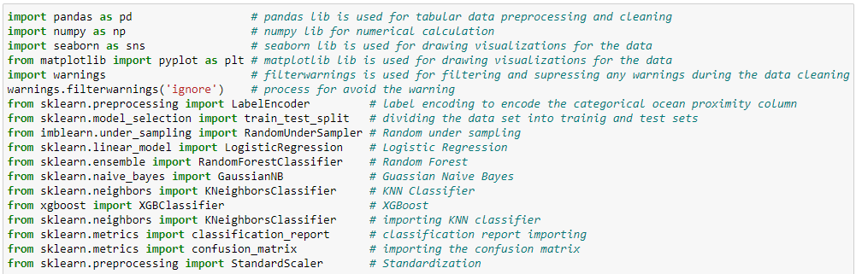

Listing 4.1 Importing Libraries

## Data Loading

To load the dataset, the author leveraged the Pandas library and accomplished this task using the command pd.read_csv



Listing 4.2 Read the CSV file

Listing 4.2 shows the loading of the required dataset into Jupiter notebook after loading the dataset the following steps are explained in below.

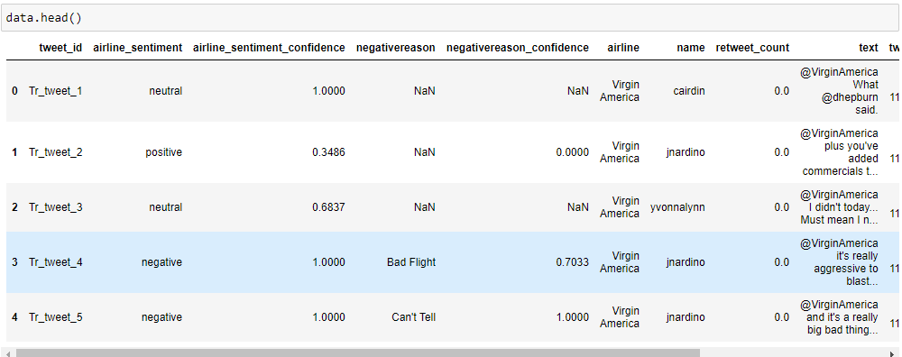

Figure 4.1 First five rows of the dataset

Fig. 4.1 displays the first five rows of the dataset. It can be displayed by using the head method.

## Data description

After importing the dataset, the author interacted with specific attributes and commands to quickly grasp the data's nature. The 'shape' attribute was employed to figure out the number of rows and columns in the dataset. Furthermore, the 'info()' command was used to identify the data types of different features. For an overall understanding of the dataset's attributes, the 'describe' function offered statistical information. The 'head' command played a key role in revealing the first five rows of the dataset. Furthermore, the 'duplicated()' command was used to examine whether there were any duplicate values in the data.

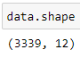

Figure 4.2 shape of the dataset

Fig. 4.2 shows the shape of the dataset it displays how many numbers of columns and rows are present in the given dataset.

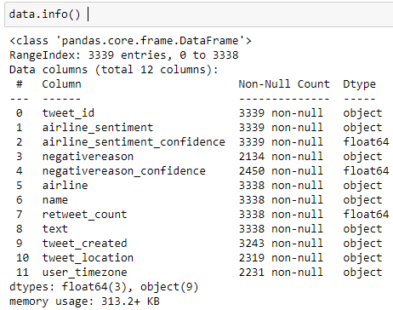

Figure 4.3 Information of the dataset

Fig. 4.3 displays the complete information about the dataset it displays the non-null values data types of the columns etc.

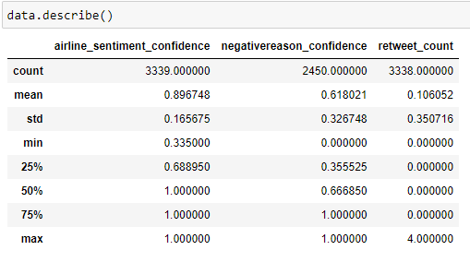

Figure 4.4 statistical information about the dataset

Fig. 4.4 displays the descriptive statistical information of the dataset it displays the min and maximum values percentile values and also displays the mean count and std values. This information will be useful for data analysis and exploration.

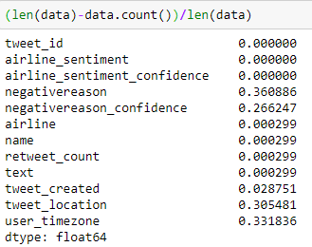

Figure 4.5 Checking the Null Values Count

Fig 4.5 provided code the Data Frame for any absent data points and computes the proportion of absent values in each column. It presents the findings in a compact overview, indicating both the quantity of absent values and the corresponding percentage for every column. This insight aids in making decisions about managing missing data during initial data preparation and contributes to comprehending the overall data quality.

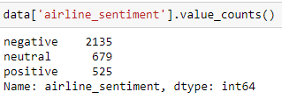

Figure 4.6 Unique value of target column

Fig 4.6 shows the frequency of each unique value in the airline_sentiment column of the data DataFrame. It returns a Series where the index represents the unique values in the column (e.g., positive sentiment, negative sentiment, neutral sentiment), and the corresponding values are the counts of each unique value. This gives insight into the distribution of sentiments in the airline_sentiment column.

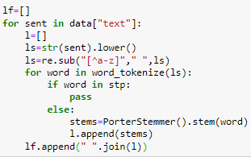

Listing 4.3 Cleaning the Text Column

Listing 4.3 shows the code processes each text in the "text" column of the "data" dataset by converting it to lowercase, removing non-alphabetic characters, removing stop words, and stemming the remaining words. The pre-processed text is then collected into the "lf" list. This type of pre-processing is common to clean and prepare text data for natural language processing tasks like sentiment analysis or text classification.

## Data Visualization

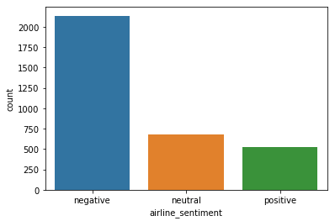

Figure 4.7 count plot for airline_sentiment

Fig 4.7 generates a graphical representation known as a count plot, illustrating how sentiments are spread across different categories (negative, neutral, and positive) within the "airline_sentiment" column of the dataset. The horizontal axis of the plot depicts the sentiment categories, and the vertical axis shows the count of occurrences for each category. By specifying the order of display as "negative," "neutral," and "positive," the code arranges the categories accordingly. The plt.show() instruction is employed to render and display the produced plot

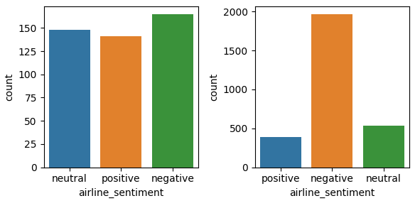

Figure 4.8 Distribution of sentiment categories

Fig 4.8 shows set of plots organized in a grid pattern, where each individual plot presents the distribution of sentiment categories ('negative', 'neutral', 'positive') for various airlines. On the horizontal axis, the sentiment categories are displayed, while the vertical axis represents the count of occurrences. The plots are grouped according to different airlines. This code provides a comprehensive visual insight into how sentiment distribution varies across airlines and their corresponding sentiment categories.

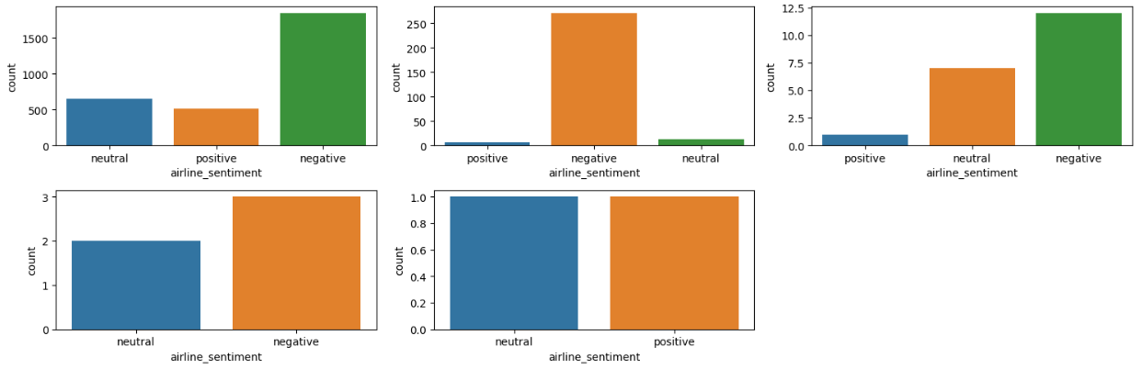

Figure 4.9 Airline sentiment related to tweet count

Fig 4.9 shows the Utilizing seaborn's factor plots to visually depict how 'airline_sentiment' is related to 'tweet_count'. The x-axis presents sentiment categories ('negative', 'neutral', 'positive'), and the y-axis illustrates the count of instances. These factor plots are structured in a grid, categorized by distinct 'retweet_count' values. The settings manage the layout, dimensions, and axis sharing. The resulting plots provide an understanding of sentiment fluctuations across diverse retweet counts. The plt.show() command showcases the produced plots

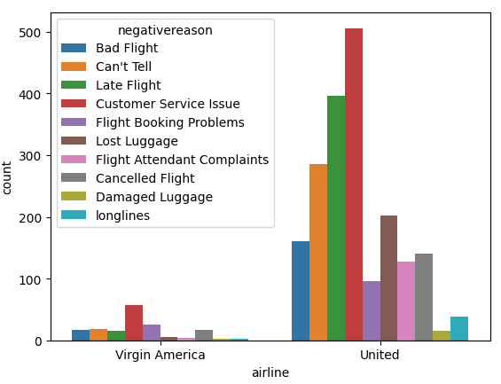

Figure 4.10 Distribution of negative reasons

Fig. 4.10 creates a factor plot that illustrates the distribution of negative reasons across different airlines, specifically 'Virgin America' and 'United'. The horizontal axis depicts the airlines, and the vertical axis shows the count of occurrences. Distinct colors are used to differentiate various negative reasons. This plot offers insights into the variability of negative reasons between the two airlines.

**Word Clouds**

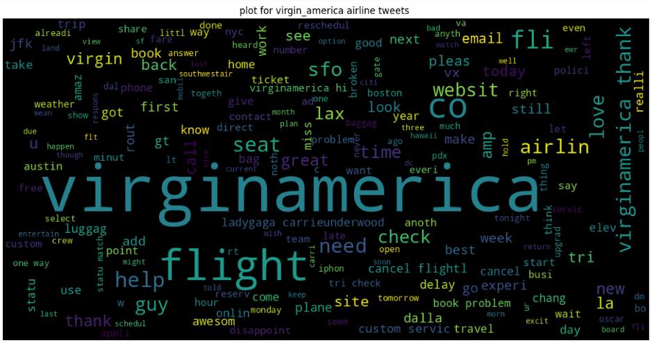

Figure 4.11 Word Cloud for Virgin America Airline

As shown in Fig 4.11, the overall word cloud for all tweets is shown.

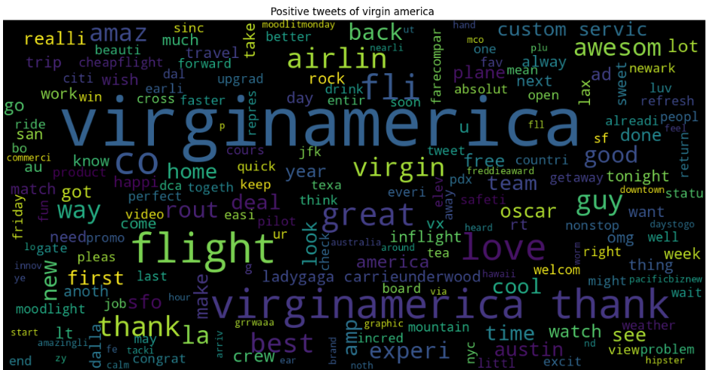

Figure 4.12 Word Cloud for Positive Tweets of Virgin America Airline

As shown in Fig 4.12, the overall word cloud for all postive tweets is shown. It consists of positive words like aweson, thank, love etc,.

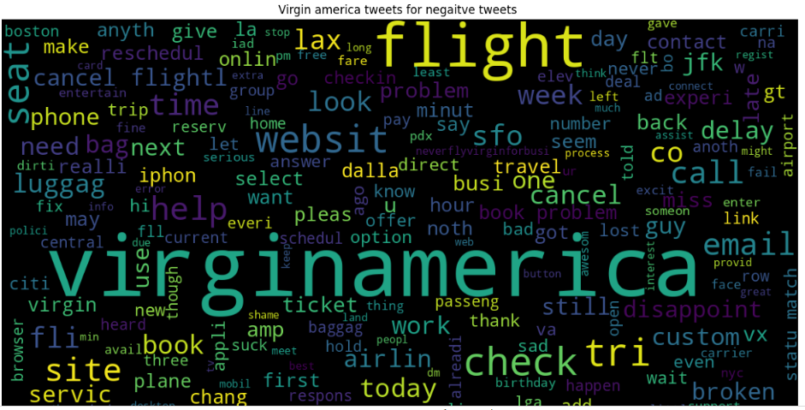

Figure 4.13 Word Cloud for Negative Tweets of Virgin America Airline

As shown in Fig 4.13, the overall word cloud for all postive tweets is shown. It consists of negative words like delay, broken, cancel flight etc,.

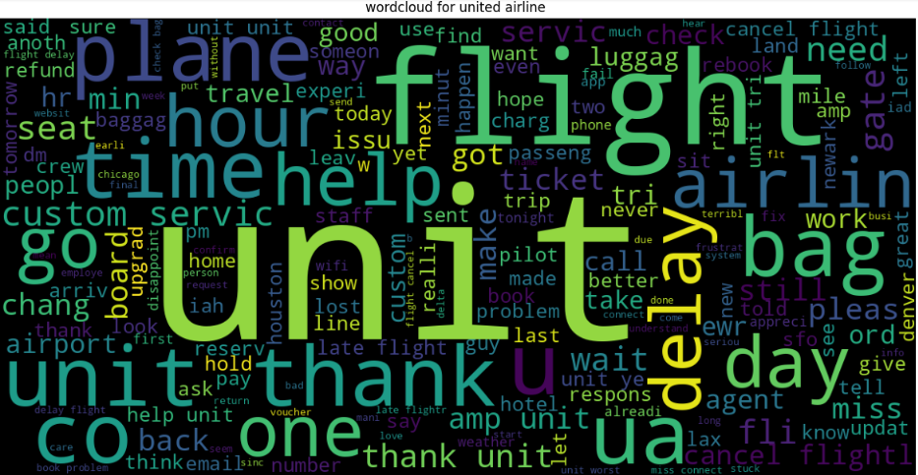

Figure 4.14 Word Cloud for Tweets of United Airline

As shown in Fig 4.14, the overall word cloud for all tweets of United Airline is shown. It consists of words like thank u, bag, day etc,.

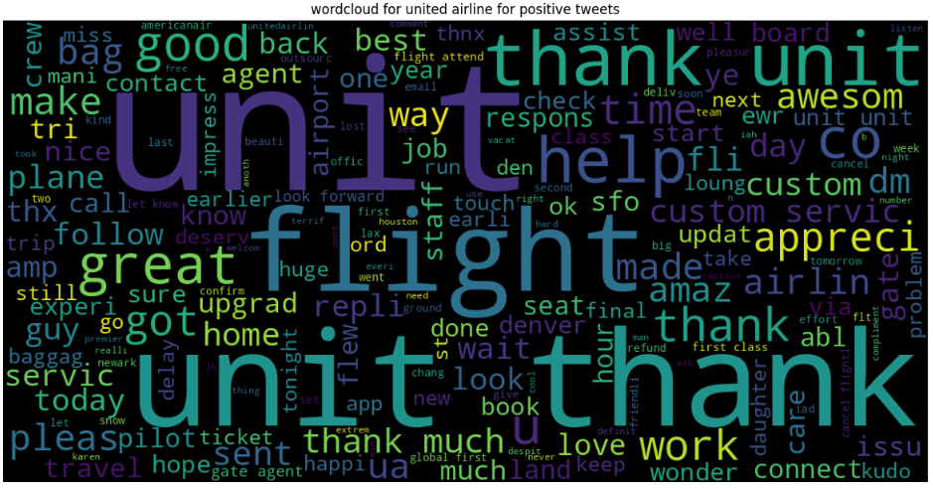

Figure 4.15 Word Cloud for Positive Tweets of United Airline

As shown in Fig 4.15, the overall word cloud for positive tweets of United Airline is shown. It consists of words like thank, awesome, appreciate etc,.

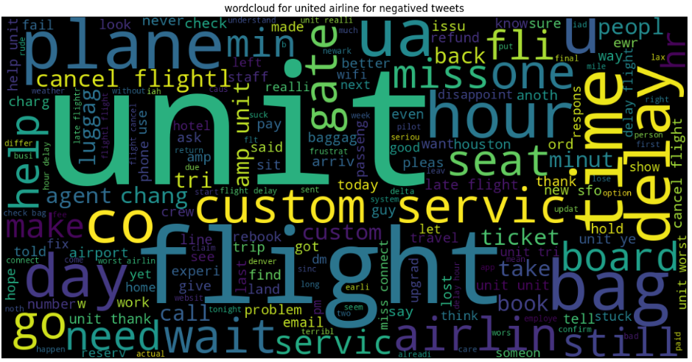

Figure 4.16 Word Cloud for Negative Tweets of United Airline

As shown in Fig 4.16, the overall word cloud for negatie tweets of United Airline is shown. It consists of words like time delay, wait, seat etc,.

## TF IDF Vectorization

TF-IDF, known as Term Frequency-Inverse Document Frequency, plays a pivotal role in natural language processing and information retrieval. It encompasses two vital elements Term Frequency (TF) and Inverse Document Frequency (IDF). TF quantifies how frequently a term appears in a document, offering insight into its relevance within that particular context. On the flip side, IDF evaluates the importance of a term across an entire collection of documents. It involves computing the logarithm of the ratio between the total number of documents and the number containing the term, ensuring a smoother computation. The TF-IDF weight for a term in a document results from multiplying its TF and IDF. This weight signifies the term's significance within the context of that specific document. Representing documents as matrices with TF-IDF weights allows them to serve as input for a range of machine learning tasks. While TF-IDF proves effective in gauging word importance in documents, it doesn't capture the contextual or semantic nuances of words. For tasks demanding a deeper comprehension of word relationships, more advanced techniques like word embedding’s are applied.



Listing 4.4 TF IDF Vectorization

Listing 4.4 shows the provided code initializes a tool known as the TfidfVectorizer instance, which is widely utilized for transforming textual data into a numerical representation. This numerical representation is particularly well-suited for various machine-learning tasks that deal with text-based information.



Listing 4.5 Data Splitting

Listing 4.5 shows the data divided into training and testing sets, which can be used to train a machine learning model on the training data and then evaluate its performance on the testing data to assess how well it generalizes to new, unseen data

## Data Modeling

**Logistic regression**

Logistic regression is a statistical technique utilized for predicting categorical outcomes based on one or more independent variables. Unlike linear regression, which deals with continuous numerical predictions, logistic regression is specifically designed for binary classification problems. It estimates the probability of an input belonging to a particular category, employing the sigmoid function to constrain outputs between 0 and 1.

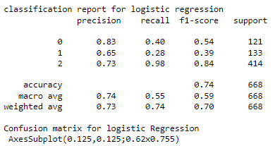

Figure 4.17 Classification report for logistic regression

Fig. 4.17 displays the classification report for logistic regression it displays the all the values of F1 score, Precision and recall values. Logistic regression got the accuracy of 74%. Here, a logistic regression model is instantiated with the parameter multi_class set to multinomial. This indicates that the model will use a multinomial logistic regression approach, suitable for multi-class classification problems. The model is then trained on the training data (x_train, y_train).

**Random Forest**

Random Forest is a potent machine learning algorithm falling under the ensemble learning category. It stands out for its ability to create a multitude of decision trees during training and subsequently aggregating their outputs to make predictions. This ensemble approach enhances accuracy and reduces the risk of overfitting. By employing a technique called Bootstrap Aggregating (Bagging), Random Forest repeatedly samples data with replacement, training individual trees on these subsets. Additionally, it introduces an element of randomness by selecting different subsets of features at each decision point in the tree.

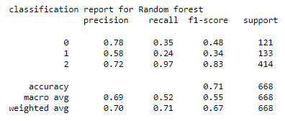

Figure 4.18 Classification Report For random forest

Fig 4.18 shows the classification report presented evaluates the performance of a classification model, possibly a Random Forest classifier, on a dataset consisting of three distinct classes labeled as 0, 1, and 2. This report offers a comprehensive assessment of the model's predictive capabilities, encompassing several vital metrics for each class as well as an overall evaluation. It displays precision recall and F1-score values. Got the accuracy of 71%.

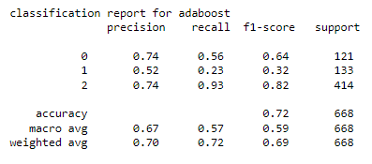

Figure 4.19 Adaboost Regression

Fig 4.19 shows the classification report for the adaboost algorithm. It displays the accuracy of 72%. As well as it will also display the macro avg and weighted avg values. Adaboost is one of the ensembles learning technique it combines the multiple weak learners into one strong model. It uses the decision stumps in the internal working of the model.

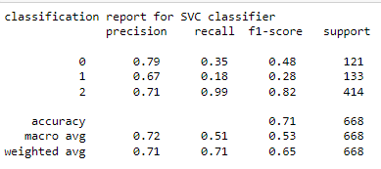

Figure 4.20 Classification report for SVM

Fig 4.20 displays the performance metrics of the SVM algorithm it will display all the values of accuracy, precision, recall and accuracy values. The accuracy of the SVM algorithm is 71 %.

## Final Result of The Project

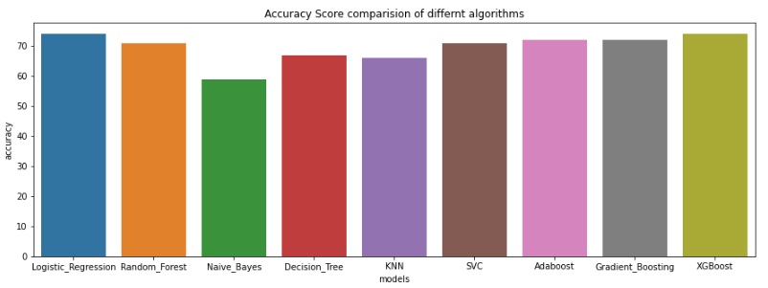

Figure 4.21 Accuracy report for all the Algorithms

Fig 4.21 Shows the bar plot using Seaborn to compare the accuracy scores of different algorithms or models. The plot is displayed with specified dimensions, and the title provides context for understanding the plot's content. This type of visualization helps to easily identify which algorithm or model performs better in terms of accuracy. out of all the algorithms logistic regression having the highest accuracy with 74 % and the second highest accuracy 72% of random forest algorithm. And the least accuracy having the naive bayes algorithm.

## Summary

This study focuses on performing airline sentiment analysis using Natural Language Processing (NLP) techniques. The initial phase involves importing essential libraries and loading the airline-related dataset into a Pandas data frame. After data loading, a thorough check is conducted for duplicate entries and missing values, which are subsequently managed. The exploration of the dataset is facilitated by visualizations, aiding in comprehending and extracting insights from the data. The pre-processing stage includes TF IDF vectorization encoding the text column in the given dataset. Creating distinct sets for training and testing is the subsequent step, enabling the data to be fed into various machine learning algorithms. In this study, diverse machine learning algorithms, including Random Forest, Support Vector Machine (SVM), Decision Tree, and boosting algorithms, are employed to construct predictive models. These models aim to accurately classify the sentiment expressed in airline-related text data, offering valuable insights into passenger experiences and opinions.

# Conclusions, Recommendations, and Future Scope

## Conclusion

In this word, a comprehensive exploration of sentiment analysis using various machine learning algorithms on Twitter data related to airline sentiments are presented Sentiment analysis is vital for the airline industry due to its numerous benefits. It serves as a vital tool for assessing customer satisfaction levels, pinpointing areas for improvement, and managing potential crises. Airlines can use sentiment analysis to not only gauge their own performance but also to gain a competitive edge by comparing their sentiment scores with those of rivals. Furthermore, it aids in optimizing routes, services, and product offerings based on passenger preferences, ultimately enhancing the overall travel experience. The dataset contained 3339 rows and 12 columns, with features including tweet text, airline sentiment, and other attributes related to the tweets. Cleaning the text data, which included lowercasing, removing non-alphabetic characters, and stemming words. This step was crucial for text-based analysis. Null values in the text column were dropped to ensure data integrity. Feature Engineering included encoding the target variable, airline_sentiment, into numerical values (0 for positive, 1 for neutral, and 2 for negative) to make it compatible with machine learning algorithms. TF-IDF vectorization was applied to convert the cleaned text data into numerical features, allowing us to use it in machine learning models. In this work various ML classification algorithms like LR, RF, GNB, DT, KNN, SVM, Adaboost, Gradient Boosting and XGBoost. LR was observed to be best performing and therefore this model is selected as final model for this work. For class 2 (positive sentiment), the model performed admirably with a high precision of 0.73 and an exceptional recall of 0.98, resulting in an impressive F1-score of 0.84. This suggests the model excelled in identifying and correctly classifying positive sentiments. However, for class 0 (negative sentiment) and class 1 (neutral sentiment), the model showed room for improvement, as indicated by lower precision (0.83 for class 0 and 0.65 for class 1) and recall (0.40 for class 0 and 0.28 for class 1) scores, resulting in F1-scores of 0.54 and 0.39, respectively. Nevertheless, the model achieved an overall accuracy of 0.74, signifying its ability to correctly predict sentiment labels in the test dataset.

## Recommendation

Firstly, the quality and quantity of data are fundamental. Collecting more extensive and diverse data from various platforms and sources can provide a more comprehensive understanding of passenger sentiment. Moreover, ensuring data cleanliness through advanced text cleaning techniques is paramount. Emojis, special characters, and abbreviations should be effectively handled to capture nuanced sentiments accurately. Addressing class imbalance is another vital step. The neutral sentiment class, often underrepresented, needs careful attention. Employing strategies like oversampling, undersampling, or synthetic data generation can prevent bias towards the majority class, resulting in a more balanced dataset.

Feature engineering plays a crucial role in sentiment analysis. Experimenting with feature selection techniques can help identify the most informative words or phrases, reducing dimensionality and improving model efficiency. Additionally, exploring word embeddings, such as Word2Vec or GloVe, can enhance the model's understanding of context and semantic relationships within the text. Model selection and fine-tuning are pivotal in achieving accurate sentiment analysis. Ensembling models, such as Random Forest or Gradient Boosting, can combine the strengths of multiple models for superior results. Hyperparameter tuning, aided by techniques like grid search or Bayesian optimization, ensures that the model operates at its best.

Interpretability should not be overlooked. Employing model explainability techniques like LIME or SHAP can shed light on the model's decision-making process, building trust and facilitating a deeper understanding of predictions. Error analysis is essential for improvement. Identifying common misclassification patterns can guide targeted model enhancements. Collaboration with domain experts within the airline industry can offer valuable insights and domain-specific lexicons to improve accuracy further. Continuous learning plays a vital role. Regularly updating and retraining the model ensures that it adapts to evolving language patterns and sentiment trends over time. Custom evaluation metrics aligned with specific business objectives are critical. These metrics can provide more tailored insights into sentiment analysis and guide decision-making accordingly.

Scalability is crucial in managing large volumes of data efficiently. Ensuring that the infrastructure supporting the sentiment analysis pipeline is scalable is essential as the project expands. User feedback is a valuable resource. Establishing a feedback loop with users and stakeholders allows for the gathering of real-world insights, suggestions, and feedback, facilitating continuous improvement.

## Future Scope

Some of the real-time analysis can be considered for airlines sentiment analysis are listed below:

* Real-time Analysis: Enable real-time sentiment analysis to respond swiftly to emerging trends, customer feedback, and potential crises on social media. This can involve building a robust streaming data pipeline and employing real-time machine learning models.
* Multilingual Support: Extend the sentiment analysis to support multiple languages, catering to a global audience. Implementing machine translation and multilingual sentiment models can be valuable for international airlines.
* Sentiment Trends: Develop predictive models to forecast sentiment trends over time. This can help airlines anticipate changes in customer sentiment and proactively adjust services and marketing strategies.
* Personalization: Customize sentiment analysis for individual customers by considering historical data and preferences. Personalized responses and recommendations can enhance the passenger experience.
* Sentiment Feedback Loop: Establish a feedback loop by integrating sentiment analysis results into customer relationship management (CRM) systems. This enables airlines to track and manage customer sentiment and experiences more effectively.
* Social Listening: Extend sentiment analysis to social listening, where airlines actively monitor social media channels for mentions and discussions related to their brand. This can help in identifying emerging issues and responding promptly.

# References

Ahani, A., Nilashi, M., Zogaan, W.A., Samad, S., Aljehane, N.O., Alhargan, A., Mohd, S., Ahmadi, H. and Sanzogni, L., 2021. Evaluating medical travelers’ satisfaction through online review analysis. Journal of Hospitality and Tourism Management, 48, pp.519-537.

Ahmed, Z., Yaseen, A.R., Hussain, S., Jamro, F. and Saeed, T., 2022. Sentiment Analysis of Twitter Data for Better Services of Airlines Using Classifier-Model Algorithms, AI, and NLP Techniques. Current Trends in Information Technology, 12(3), pp.29-46p.

Ajah, I.A. and Nweke, H.F., 2019. Big data and business analytics: Trends, platforms, success factors and applications. Big Data and Cognitive Computing, 3(2), p.32.

Alantari, H.J., Currim, I.S., Deng, Y. and Singh, S., 2022. An empirical comparison of machine learning methods for text-based sentiment analysis of online consumer reviews. International Journal of Research in Marketing, 39(1), pp.1-19.

Aljedaani, W., Rustam, F., Mkaouer, M.W., Ghallab, A., Rupapara, V., Washington, P.B., Lee, E. and Ashraf, I., 2022. Sentiment analysis on Twitter data integrating TextBlob and deep learning models: The case of US airline industry. Knowledge-Based Systems, 255, p.109780.

Ankaräng, F. and Waldner, F., 2019. Evaluating Random Forest and a Long Short-Term Memory in Classifying a Given Sentence as a Question or Non-Question.

Aria, M., Cuccurullo, C. and Gnasso, A., 2021. A comparison among interpretative proposals for Random Forests. Machine Learning with Applications, 6, p.100094.

Ashi, M.M., Siddiqui, M.A. and Nadeem, F., 2019. Pre-trained word embeddings for Arabic aspect-based sentiment analysis of airline tweets. In Proceedings of the International Conference on Advanced Intelligent Systems and Informatics 2018 4 (pp. 241-251). Springer International Publishing.

Boddu, R.S.K., Santoki, A.A., Khurana, S., Koli, P.V., Rai, R. and Agrawal, A., 2022. An analysis to understand the role of machine learning, robotics and artificial intelligence in digital marketing. Materials Today: Proceedings, 56, pp.2288-2292.

Budhiraja, A. and Sharma, K., 2023, April. Decisions Prediction Techniques Using Language Processing and Learning Algorithms. In Proceedings of 3rd International Conference on Artificial Intelligence: Advances and Applications: ICAIAA 2022 (pp. 107-121). Singapore: Springer Nature Singapore.

Chang, Y.C., Ku, C.H. and Le Nguyen, D.D., 2022. Predicting aspect-based sentiment using deep learning and information visualization: The impact of COVID-19 on the airline industry. Information & Management, 59(2), p.103587.

Choi, J., Yoon, J., Chung, J., Coh, B.Y. and Lee, J.M., 2020. Social media analytics and business intelligence research: A systematic review. Information Processing & Management, 57(6), p.102279.

Deepa, D. and Tamilarasi, A., 2019, December. Sentiment analysis using feature extraction and dictionary-based approaches. In 2019 Third International conference on I-SMAC (IoT in Social, Mobile, Analytics and Cloud)(I-SMAC) (pp. 786-790). IEEE.

Deng, H., Zhou, Y., Wang, L. and Zhang, C., 2021. Ensemble learning for the early prediction of neonatal jaundice with genetic features. *BMC medical informatics and decision making*, *21*, pp.1-11.

Downie, J., 2019. Interpreters vs machines: can interpreters survive in an AI-dominated world?. Routledge.

Dwivedi, Y.K., Ismagilova, E., Hughes, D.L., Carlson, J., Filieri, R., Jacobson, J., Jain, V., Karjaluoto, H., Kefi, H., Krishen, A.S. and Kumar, V., 2021. Setting the future of digital and social media marketing research: Perspectives and research propositions. International Journal of Information Management, 59, p.102168.

Ebrahim, M., 2023. Development of Stemming Algorithm for Guragegna Text (Doctoral dissertation, St. Mary’s University).

Farzadnia, S. and Vanani, I.R., 2022. Identification of opinion trends using sentiment analysis of airlines passengers' reviews. Journal of Air Transport Management, 103, p.102232.

Ferreira, C., Robertson, J., Chohan, R., Pitt, L. and Foster, T., 2023. The writing is on the wall: predicting customers' evaluation of customer-firm interactions using computerized text analysis. Journal of Service Theory and Practice, 33(2), pp.309-327.

Ganaie, M.A., Hu, M., Malik, A.K., Tanveer, M. and Suganthan, P.N., 2022. Ensemble deep learning: A review. Engineering Applications of Artificial Intelligence, 115, p.105151.

Gupta, N. and Bhargav, R., 2022. Sentiment Analysis in Airlines Industry Using Machine Learning Techniques. In Emerging Technologies in Data Mining and Information Security: Proceedings of IEMIS 2022, Volume 2 (pp. 99-111). Singapore: Springer Nature Singapore.

Hasib, K.M., 2022. Sentiment analysis on Bangladesh airlines review data using machine learning (Doctoral dissertation, Brac University).

Hasib, K.M., Habib, M.A., Towhid, N.A. and Showrov, M.I.H., 2021, February. A novel deep learning based sentiment analysis of twitter data for us airline service. In *2021 International Conference on Information and Communication Technology for Sustainable Development (ICICT4SD)* (pp. 450-455). IEEE.

Higgins, L., 2022. Classification of Airline Customer Sentiment Expressed in Twitter Tweets using Lexicons, Decision Tree, and Naïve Bayes (Doctoral dissertation, Dublin, National College of Ireland).

Ibrahim, N.F. and Wang, X., 2019. A text analytics approach for online retailing service improvement: Evidence from Twitter. Decision Support Systems, 121, pp.37-50.

Iqbal, F., Hashmi, J.M., Fung, B.C., Batool, R., Khattak, A.M., Aleem, S. and Hung, P.C., 2019. A hybrid framework for sentiment analysis using genetic algorithm based feature reduction. IEEE Access, 7, pp.14637-14652.

Iqbal, Z., Yadav, M. and Masood, I.S., 2020. Implementation of supervised learning techniques for sentiment analysis of customer Tweets on airline services. *Int. J. Eng. Appl. Sci. Technol*, *5*(3), pp.351-357.

Jain, P.K., Quamer, W., Saravanan, V. and Pamula, R., 2023. Employing BERT-DCNN with sentic knowledge base for social media sentiment analysis. Journal of Ambient Intelligence and Humanized Computing, 14(8), pp.10417-10429.

Johri, P., Khatri, S.K., Al-Taani, A.T., Sabharwal, M., Suvanov, S. and Kumar, A., 2021. Natural language processing: History, evolution, application, and future work. In Proceedings of 3rd International Conference on Computing Informatics and Networks: ICCIN 2020 (pp. 365-375). Springer Singapore.

Kaur, G. and Malik, K., 2022. A Sentiment Analysis of Airline System using Machine Learning Algorithms. International Journal of Advanced Research in Engineering, 12(1), pp.731-742.

Keke, M.E., 2023. Impact of digital marketing on the aviation industry. In E3S Web of Conferences (Vol. 402, p. 02009). EDP Sciences.

Kumar, S. and Zymbler, M., 2019. A machine learning approach to analyze customer satisfaction from airline tweets. Journal of Big Data, 6(1), pp.1-16.

Kumar, S., Kar, A.K. and Ilavarasan, P.V., 2021. Applications of text mining in services management: A systematic literature review. International Journal of Information Management Data Insights, 1(1), p.100008.

Kwon, H.J., Ban, H.J., Jun, J.K. and Kim, H.S., 2021. Topic modeling and sentiment analysis of online review for airlines. Information, 12(2), p.78.

Kwon, H.J., Ban, H.J., Jun, J.K. and Kim, H.S., 2021. Topic modeling and sentiment analysis of online review for airlines. *Information*, *12*(2), p.78.

Li, R., 2020. Artificial intelligence revolution: How AI will change our society, economy, and culture. Simon and Schuster.

Ligthart, A., Catal, C. and Tekinerdogan, B., 2021. Systematic reviews in sentiment analysis: a tertiary study. Artificial Intelligence Review, pp.1-57.

Lucini, F.R., Tonetto, L.M., Fogliatto, F.S. and Anzanello, M.J., 2020. Text mining approach to explore dimensions of airline customer satisfaction using online customer reviews. Journal of Air Transport Management, 83, p.101760.

Monika, R., Deivalakshmi, S. and Janet, B., 2019, December. Sentiment analysis of US airlines tweets using LSTM/RNN. In 2019 IEEE 9th International Conference on Advanced Computing (IACC) (pp. 92-95). IEEE.

Morgan, F.E., Boudreaux, B., Lohn, A.J., Ashby, M., Curriden, C., Klima, K. and Grossman, D., 2020. Military applications of artificial intelligence. Santa Monica: RAND Corporation.

Morrison, A.M., 2022. Hospitality and travel marketing. Taylor & Francis.

Nam, S. and Lee, H.C., 2019. A text analytics-based importance performance analysis and its application to airline service. Sustainability, 11(21), p.6153.

Naseem, U., Khan, S.K., Razzak, I. and Hameed, I.A., 2019. Hybrid words representation for airlines sentiment analysis. In AI 2019: Advances in Artificial Intelligence: 32nd Australasian Joint Conference, Adelaide, SA, Australia, December 2–5, 2019, Proceedings 32 (pp. 381-392). Springer International Publishing.

Naseem, U., Razzak, I. and Eklund, P.W., 2021. A survey of pre-processing techniques to improve short-text quality: a case study on hate speech detection on twitter. Multimedia Tools and Applications, 80, pp.35239-35266.

Osama, M., Zaki-Ismail, A., Abdelrazek, M., Grundy, J. and Ibrahim, A., 2020, September. Score-based automatic detection and resolution of syntactic ambiguity in natural language requirements. In 2020 IEEE International Conference on Software Maintenance and Evolution (ICSME) (pp. 651-661). IEEE.

Patel, A., Oza, P. and Agrawal, S., 2023. Sentiment Analysis of Customer Feedback and Reviews for Airline Services using Language Representation Model. Procedia Computer Science, 218, pp.2459-2467.

Prabhakar, E., Santhosh, M., Krishnan, A.H., Kumar, T. and Sudhakar, R., 2019. Sentiment analysis of US airline twitter data using new adaboost approach. International Journal of Engineering Research & Technology (IJERT), 7(1), pp.1-6.

Pugliese, R., Regondi, S. and Marini, R., 2021. Machine learning-based approach: Global trends, research directions, and regulatory standpoints. Data Science and Management, 4, pp.19-29.

Rahat, A.M., Kahir, A. and Masum, A.K.M., 2019, November. Comparison of Naive Bayes and SVM Algorithm based on sentiment analysis using review dataset. In 2019 8th International Conference System Modeling and Advancement in Research Trends (SMART) (pp. 266-270). IEEE.

Rathee, N., Joshi, N. and Kaur, J., 2018, June. Sentiment analysis using machine learning techniques on Python. In 2018 Second International Conference on Intelligent Computing and Control Systems (ICICCS) (pp. 779-785). IEEE.

Ravi Kumar, G., Venkata Sheshanna, K. and Anjan Babu, G., 2021. Sentiment analysis for airline tweets utilizing machine learning techniques. In *International Conference on Mobile Computing and Sustainable Informatics: ICMCSI 2020* (pp. 791-799). Springer International Publishing.

Saad, A.I., 2020, December. Opinion mining on US Airline Twitter data using machine learning techniques. In 2020 16th international computer engineering conference (ICENCO) (pp. 59-63). IEEE.

Saad, A.I., 2020, December. Opinion mining on US Airline Twitter data using machine learning techniques. In 2020 16th international computer engineering conference (ICENCO) (pp. 59-63). IEEE.

Sadeghian Broujeny, R., Ben Ayed, S. and Matalah, M., 2023. Energy Consumption Forecasting in a University Office by Artificial Intelligence Techniques: An Analysis of the Exogenous Data Effect on the Modeling. *Energies*, *16*(10), p.4065.

Shafi, A.S.M., Molla, M.I., Jui, J.J. and Rahman, M.M., 2020. Detection of colon cancer based on microarray dataset using machine learning as a feature selection and classification techniques. SN Applied Sciences, 2, pp.1-8.

Sharma, A. and Ghose, U., 2020. Sentimental analysis of twitter data with respect to general elections in India. Procedia Computer Science, 173, pp.325-334.

Shen, J. and Shafiq, M.O., 2020. Short-term stock market price trend prediction using a comprehensive deep learning system. Journal of big Data, 7(1), pp.1-33.

Sreeja, I., Sunny, J.V. and Jatian, L., 2020. Twitter sentiment analysis on airline tweets in India using R language. In Journal of Physics: Conference Series (Vol. 1427, No. 1, p. 012003). IOP Publishing.

Sreeja, I., Sunny, J.V. and Jatian, L., 2020. Twitter sentiment analysis on airline tweets in India using R language. In Journal of Physics: Conference Series (Vol. 1427, No. 1, p. 012003). IOP Publishing.

Sykora, M., Elayan, S., Hodgkinson, I.R., Jackson, T.W. and West, A., 2022. The power of emotions: Leveraging user generated content for customer experience management. Journal of Business Research, 144, pp.997-1006.

Tan, K.L., Lee, C.P. and Lim, K.M., 2023. A survey of sentiment analysis: Approaches, datasets, and future research. Applied Sciences, 13(7), p.4550.

Tusar, M.T.H.K. and Islam, M.T., 2021, September. A comparative study of sentiment analysis using NLP and different machine learning techniques on US airline Twitter data. In 2021 International Conference on Electronics, Communications and Information Technology (ICECIT) (pp. 1-4). IEEE.

Ullah, M.A., Marium, S.M., Begum, S.A. and Dipa, N.S., 2020. An algorithm and method for sentiment analysis using the text and emoticon. ICT Express, 6(4), pp.357-360.

Vajjala, S., Majumder, B., Gupta, A. and Surana, H., 2020. Practical natural language processing: A comprehensive guide to building real-world NLP systems. O'Reilly Media.

Wang, C., Xu, S. and Yang, J., 2021. Adaboost algorithm in artificial intelligence for optimizing the IRI prediction accuracy of asphalt concrete pavement. *Sensors*, *21*(17), p.5682.

Wankhade, M., Rao, A.C.S. and Kulkarni, C., 2022. A survey on sentiment analysis methods, applications, and challenges. Artificial Intelligence Review, 55(7), pp.5731-5780.

Yogish, D., Manjunath, T.N. and Hegadi, R.S., 2019. Review on natural language processing trends and techniques using NLTK. In Recent Trends in Image Processing and Pattern Recognition: Second International Conference, RTIP2R 2018, Solapur, India, December 21–22, 2018, Revised Selected Papers, Part III 2 (pp. 589-606). Springer Singapore.

Yogish, D., Manjunath, T.N. and Hegadi, R.S., 2019. Review on natural language processing trends and techniques using NLTK. In Recent Trends in Image Processing and Pattern Recognition: Second International Conference, RTIP2R 2018, Solapur, India, December 21–22, 2018, Revised Selected Papers, Part III 2 (pp. 589-606). Springer Singapore.

Zaki Ahmed, A. and Rodríguez-Díaz, M., 2020. Significant labels in sentiment analysis of online customer reviews of airlines. Sustainability, 12(20), p.8683.